Objective C NSMutableArray

* NSMutableArray is Objective-C’s general-purpose array type.
* NSMutableArray is subclass of NSArray.
* NSMutableArray is inherited from NSArray and hence all instance methods of NSArray is available in NSMutableArray.
* NSMutableArray creates dynamic arrays.
* The NSMutableArray class lets you dynamically add or remove items from arbitrary locations in the collection.
* Mutability helps to change the array in runtime a pre allocated array.
* If we use NSMutableArray, we can change the contents of the existing array.
* NSMutableArray are often used to represent the state of a system, but the fact that NSMutableArray records the order of its elements opens up new modeling opportunities.
* NSMutableArray can record the order in which they should be fixed.

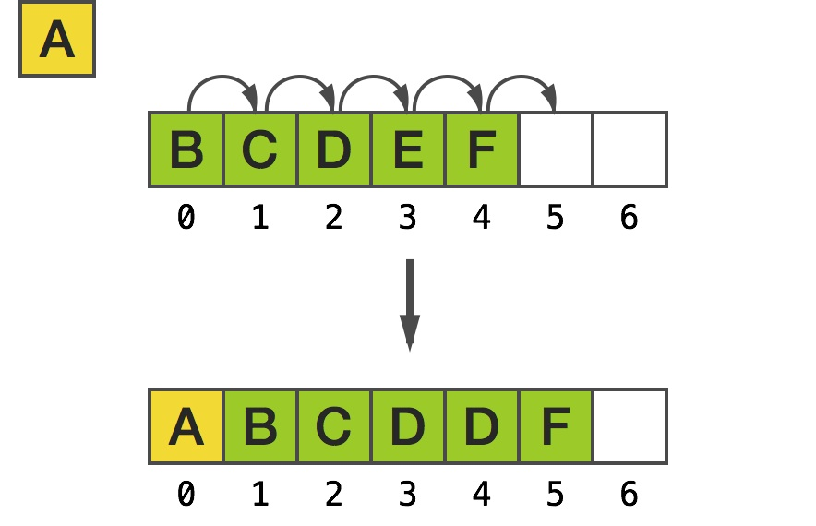

Fig a): NSMutableArray  collection classes of the Foundation Framework.

**Important methods of NSMutableArray are as follows:**

* removeAllObjects: Empties the array.
* addObject: Inserts a given object at the end of the array.
* removeObjectAtIndex: This is used to remove objectAt a specific index
* exchangeObjectAtIndex:withObjectAtIndex: Exchanges the objects in the array at given indices.
* replaceObjectAtIndex:withObject: Replaces the object at index with an Object.

## Creating Mutable Arrays:

**Example:**

NSMutableArray *brokenCars = [NSMutableArray arrayWithObjects:@"Audi A6", @"BMW Z3", @"Audi Quattro", @"Audi TT", nil];

## Adding and Removing Objects:

The two basic methods for manipulating the contents of an array are the addObject: and removeLastObject methods. The former adds an object to the end of the array, and the latter is pretty self-documenting. Note that these are also useful methods for treating an NSArray as a stack.

**Example:**

NSMutableArray *brokenCars = [NSMutableArray arrayWithObjects: @"Audi A6", @"BMW Z3", @"Audi Quattro", @"Audi TT", nil];

[brokenCars addObject:@"BMW F25"];

NSLog(@"%@", brokenCars); // BMW F25 added to end

[brokenCars removeLastObject];

NSLog(@"%@", brokenCars); // BMW F25 removed from end

**Inherits From:**

[NSObject](https://developer.apple.com/library/mac/documentation/Cocoa/Reference/Foundation/Classes/NSObject_Class/index.html#//apple_ref/occ/cl/NSObject)

NSArray

[NSMutableArray](https://developer.apple.com/library/mac/documentation/Cocoa/Reference/Foundation/Classes/NSMutableArray_Class/index.html#//apple_ref/occ/cl/NSMutableArray)

**Import Statement:**

* @import Foundation;

**Availability:**

* Available in OS X v10.0 and later

**Advantages of NSMutableArray over NSArray:**

* Changing how NSMutableArray stores the elements of its collection. You might do this for performance reasons or for better compatibility with legacy code.
* Acquiring more information about what is happening to the collection (for example, statistics gathering).

**Disadvantages:**

* In a subclass, you must override all the methods. You must also override the primitive methods of the [NSArray](https://developer.apple.com/library/mac/documentation/Cocoa/Reference/Foundation/Classes/NSArray_Class/index.html#//apple_ref/occ/cl/NSArray) class.

**References:**

* <https://developer.apple.com/library/mac/documentation/Cocoa/Reference/Foundation/Classes/NSArray_Class/index.html#//apple_ref/occ/cl/NSArray>
* <http://rypress.com/tutorials/objective-c/data-types/nsarray>
* <http://as.wiley.com/WileyCDA/Section/id-400181.html>
* <http://www.tutorialspoint.com/objective_c/objective_c_data_storage.htm>